

**Sukkur Institute of Business Administration University**

Department of Computer Science

**CSC-252: Database Management System**

**Instructor: Soonh Taj**

**Group members: Diljeet, Sooraj**

**Project Name: School Management System**

**Project Report**

School Management System

**Scope:**

As we Know that in modern period there are a lot of schools who have to maintain the record of students on daily basis. For this purpose, they use registers in which they write everything by hand but this causes a lot of mistakes, and also there is a chance that those register can be misplaces and in that case the system of school will be affected badly to solve this problem we have thought to make an application which will allow the school system to maintain their records in that. This application will provide facility through which fees record of students will be managed, enrolment of students will be recorded in this application, and record of the teacher and Expenditure of the school will be recorded through this application.

**ERD:**

**Login page:** Here we can login as either teacher or admin. Username will be the teacher ID for Teacher

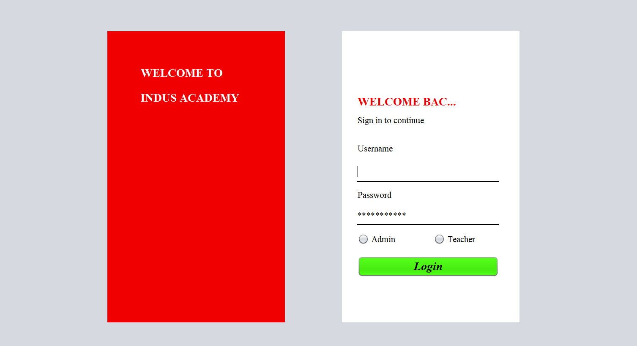

When Admin will be Login

Admin will be facilitated by following seven Main facilities and sub facilities are given in description

1. Teacher
2. Student
3. Class
4. Examinations
5. Results
6. Dashboard
7. Logout

**DASHBOARD:** dashboard shows us following tabs and it also shows no: of students and teachers in our school

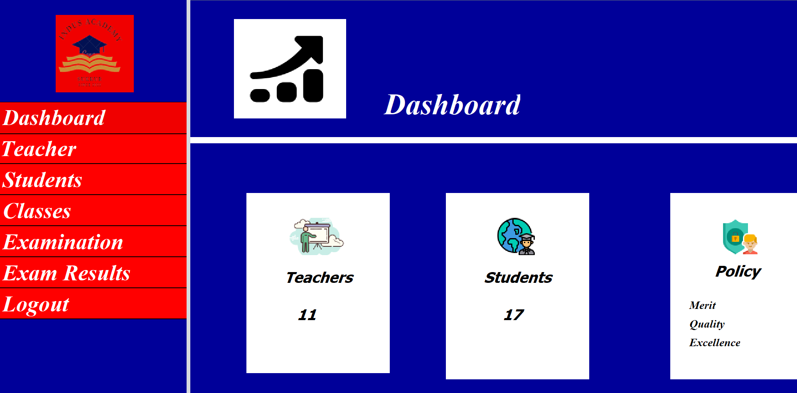

**Teacher:**  This module shows the record of teachers in our school and teachers can also be Appointed Teacher, Accept Resign and view all Resigned Teachers, in case of wrong appointed Teacher can be deleted from here. Above all activities will be performed by write click on table.

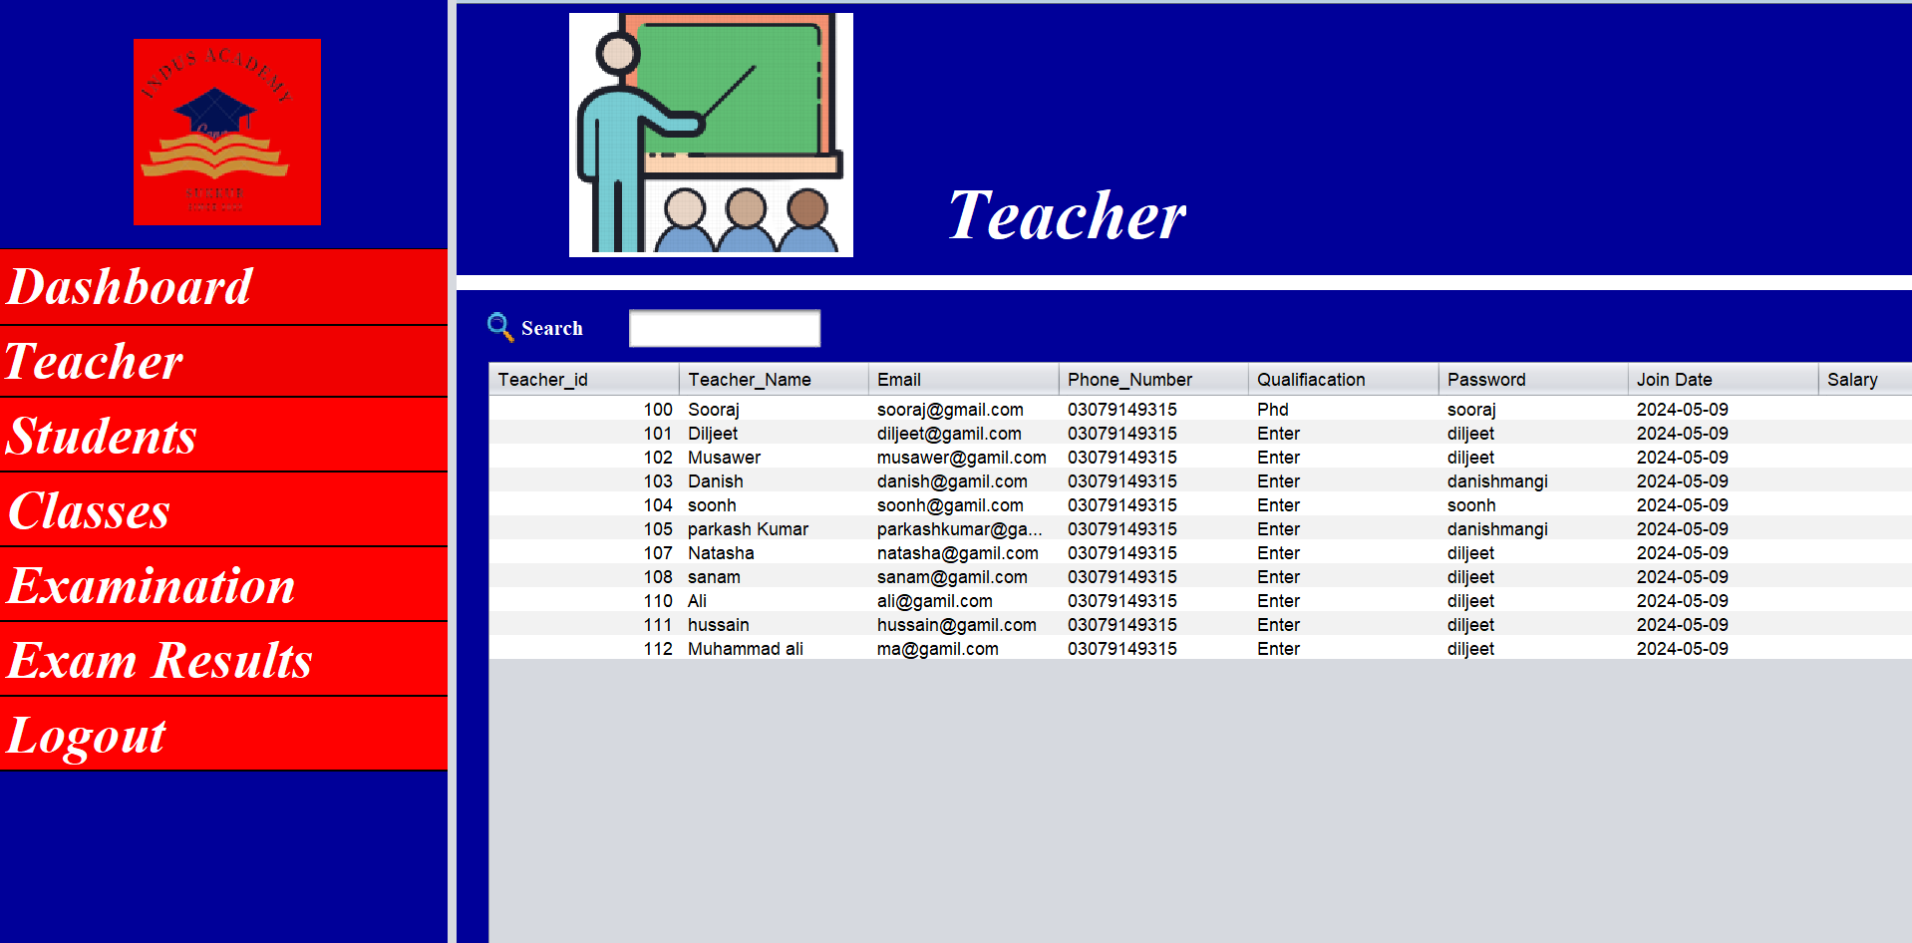

**Class:** This module shows the of classes Information of school. class module will talk about **Class name, subject and teacher** which is teaching in **class and room**.

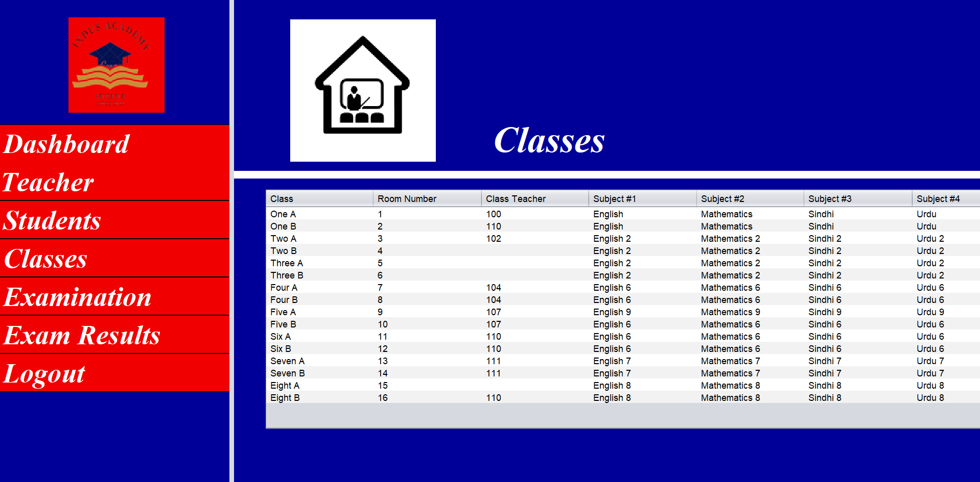

**Student:**  This module shows the record of students in our school and students. Admin can also enrol **or delete** Student Information from here by right click on record.

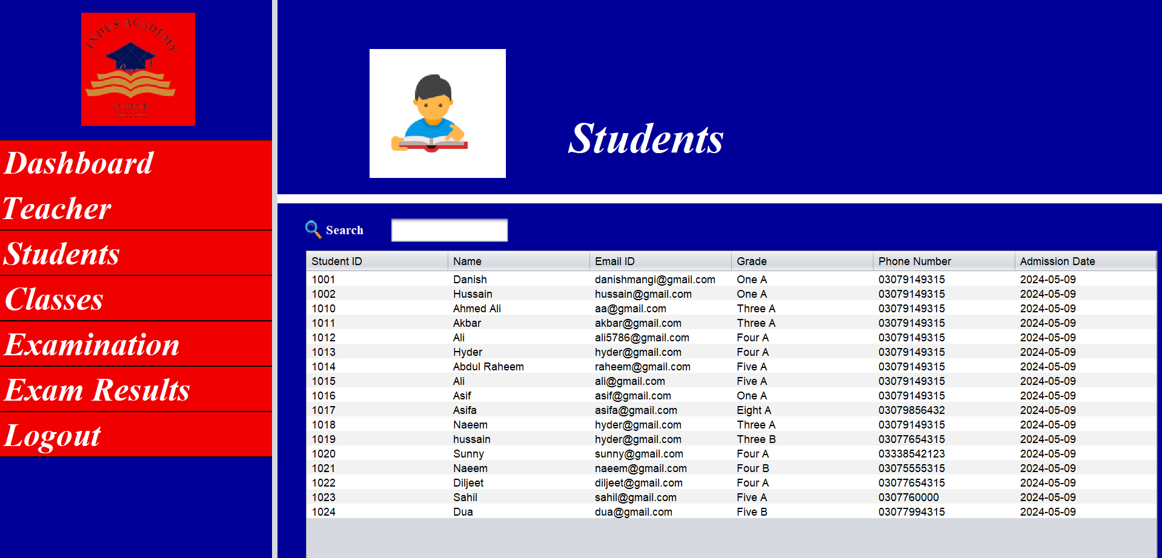

**Results:** Through this module admin can view for the result of all student which is assigned by their dedicated teacher. Admin can view that in which exam and which teacher has assigned marks to student.

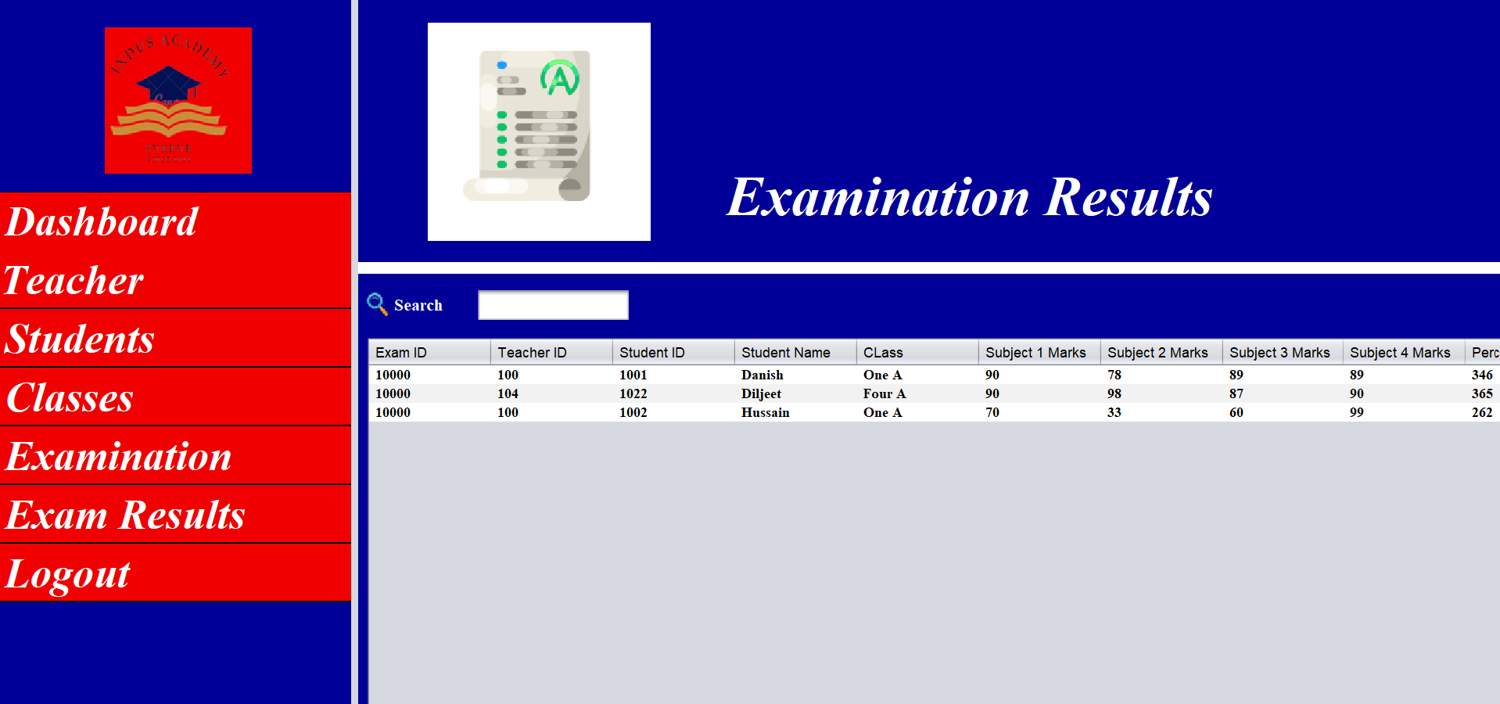

**In above all activities can be done by Admin.**

**Admin username is: 021-21-0055**

**Password is: diljeet**

**When teacher will login**

Here teacher can **view marks and assign marks** to its own students.

**View Marks:** Teacher can view the mark of student that in **which exam and how much marks has taken in each Subject.**

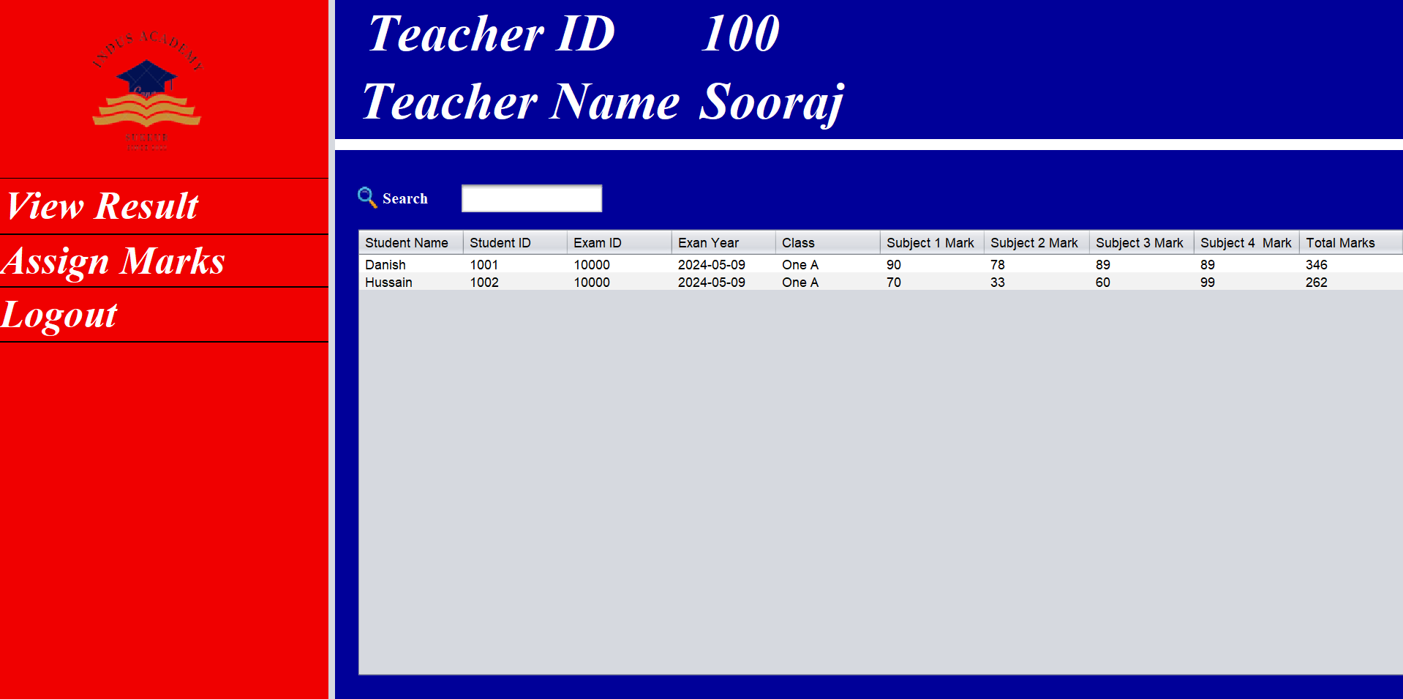

**Assign Marks:** Teacher can assign **marks and update mark** of student first select from the table of students which are enrolled with Teacher. It will take marks between (0 to 100) for both update and add marks and exam ID for identification of Exam.

* Adding Marks and update Marks

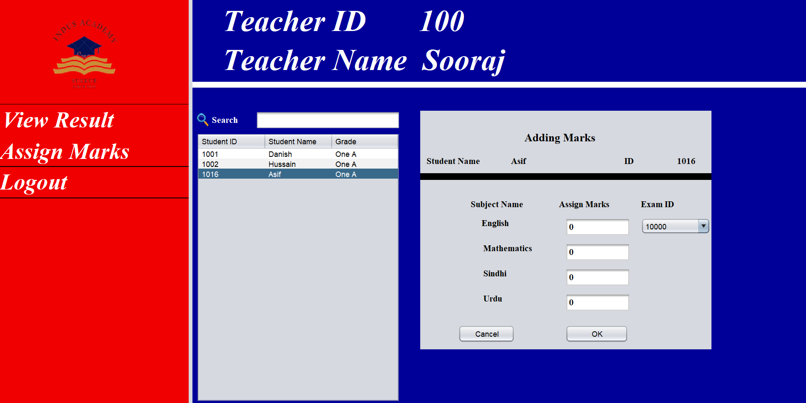

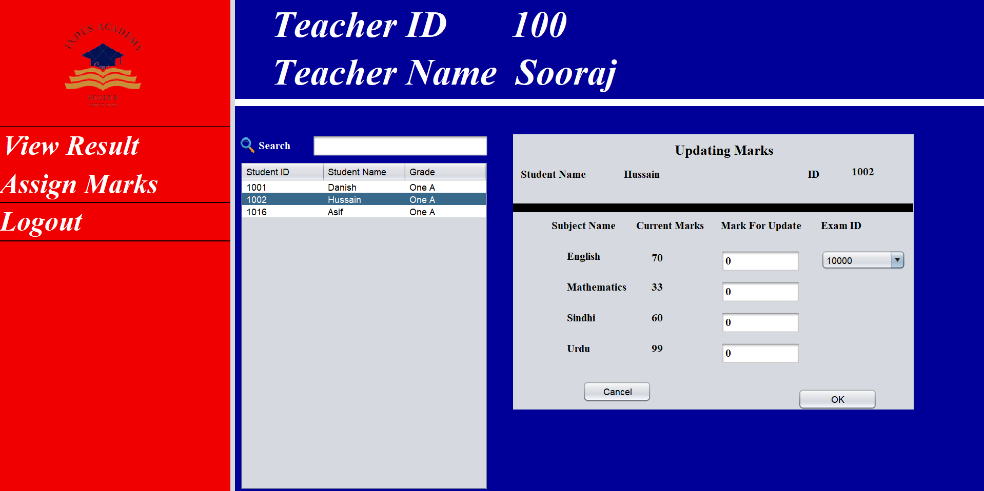

**THANK YOU.**